Project Development Phase
Model Performance Test – Metro Ticket Generating System
Date | 05 September 2026
Project Name | Metro Ticket Generating System
Maximum Marks | 4 Marks

Model Performance Testing: The following evidence documents the implemented ServiceNow application, catalog item configuration, variables, UI policy, client scripts, data records, and QR-ticket generation.
S.No. | Parameter | Screenshot / Values
1 | Data Rendered | Metro Station, Metro Route, Metro Train, Metro Ticket, Payment, Passenger Feedback, Metro Announcement and Metro Station's Details tables are available in the application.
2 | Data Preprocessing | Form inputs and application data are configured through ServiceNow tables, catalog variables, reference fields, and client-side validation/calculation logic.
3 | Utilization of Data Filters | Catalog form controls and UI policy logic are used to control field behavior and visibility. The 'Enter payment mode' field is made mandatory/visible through the Catalog UI Policy.
4 | DAX Queries Used | Not Applicable – the project is implemented in ServiceNow; DAX/Power BI queries are not used.
5 | Dashboard Design | No dashboard evidence was provided in the supplied screenshots; therefore no dashboard count is claimed.
6 | Report Design | No report evidence was provided in the supplied screenshots; therefore no report visualization count is claimed.

Implementation Evidence
Screenshot 1 – ServiceNow table list showing Metro and MediSync application tables.
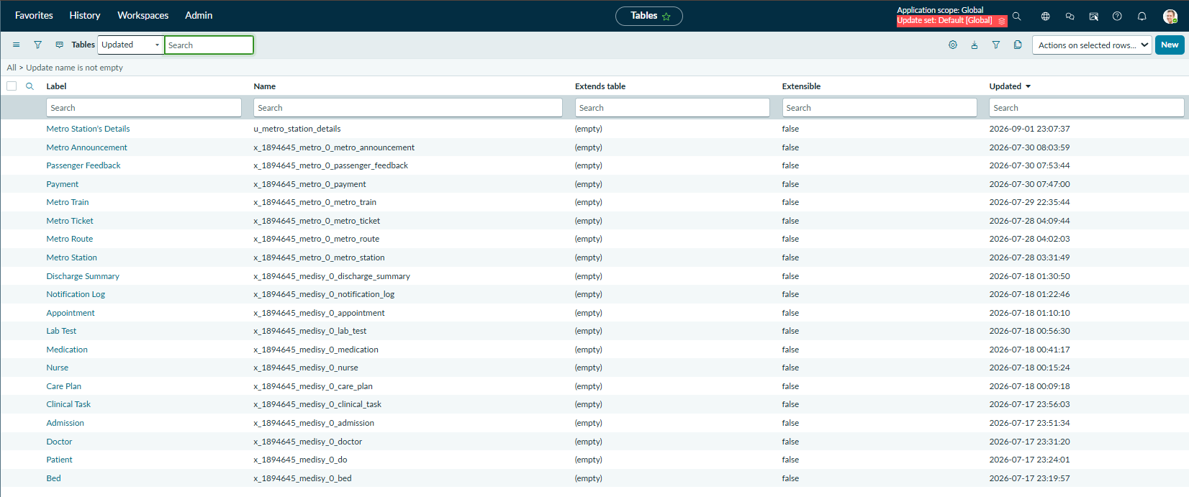
Screenshot 2 – Metro Station's Details table definition and columns.
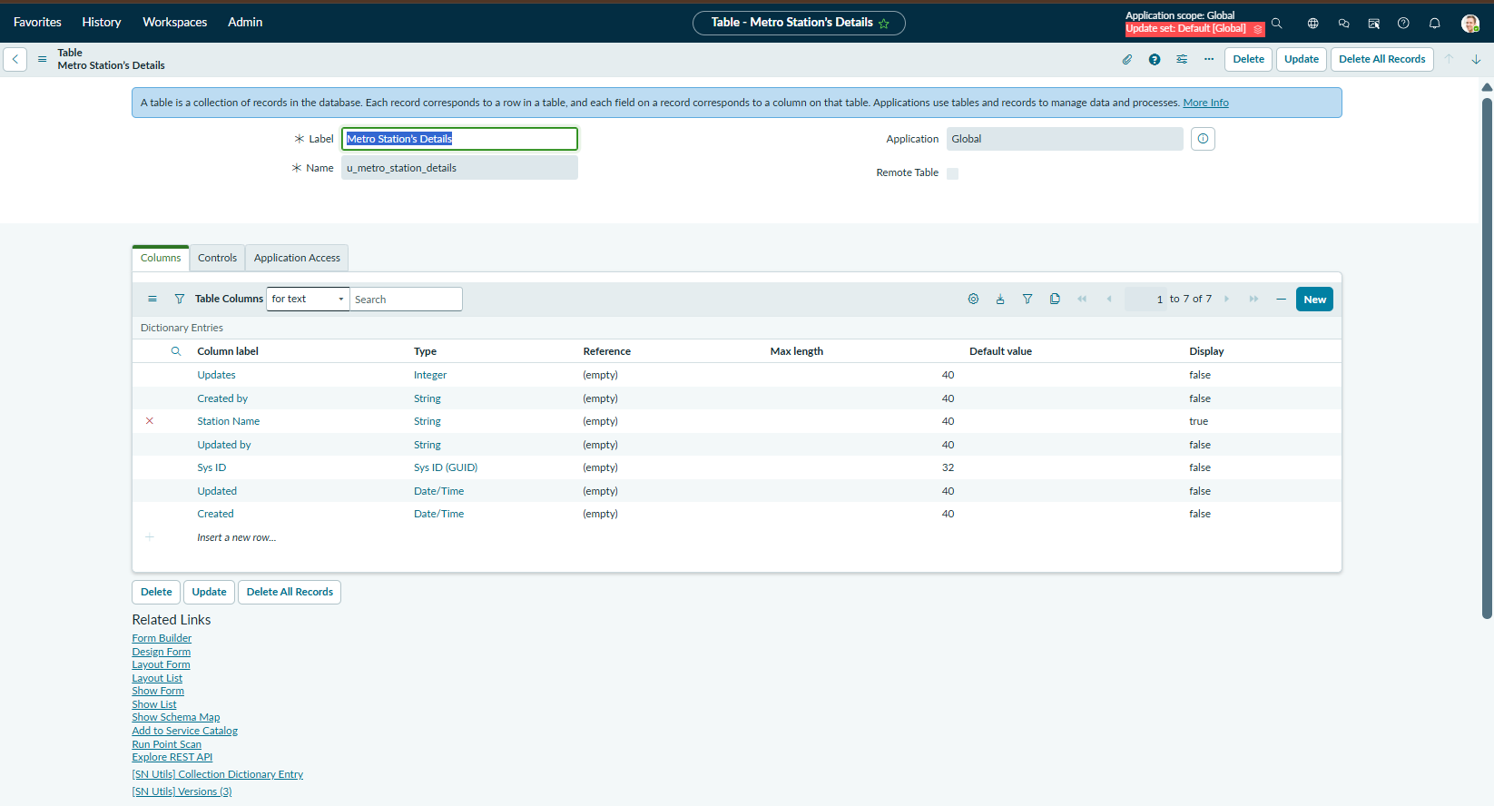
Screenshot 3 – Access Controls for Metro Station's Details table.
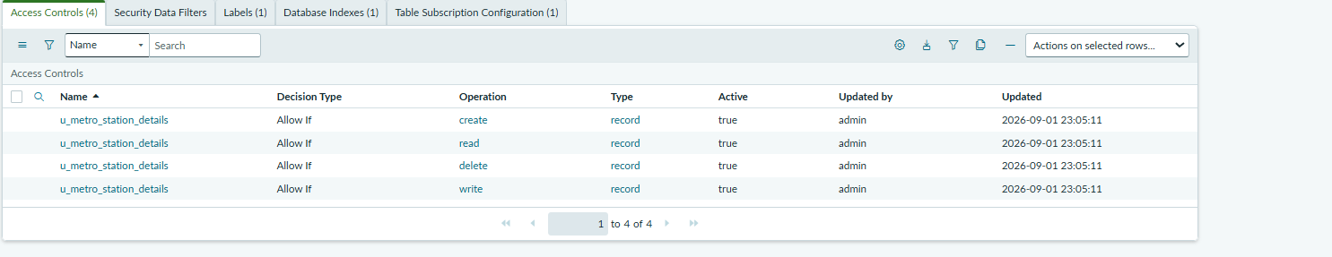
Screenshot 4 – Service Catalog list including the Book A Metro Ticket catalog item.
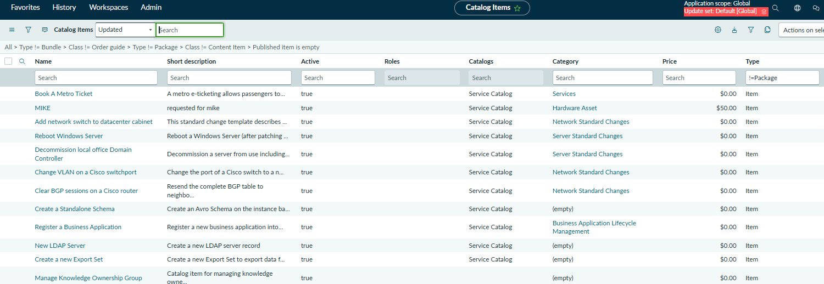
Screenshot 5 – Book A Metro Ticket catalog item configuration.
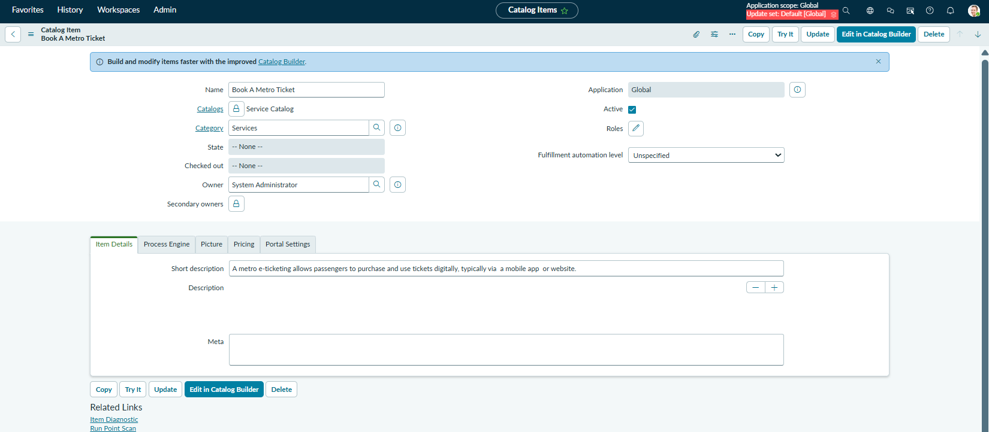
Screenshot 6 – Catalog variables configured for the ticket booking form.
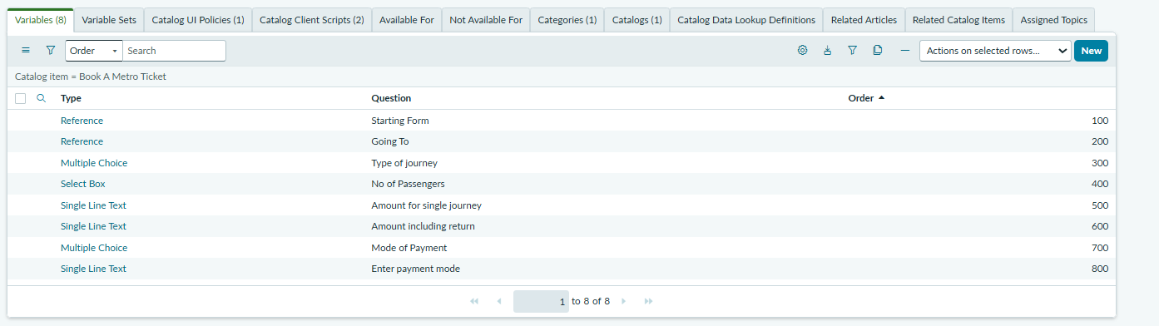
Screenshot 7 – Catalog UI Policy controlling field visibility/mandatory behavior.
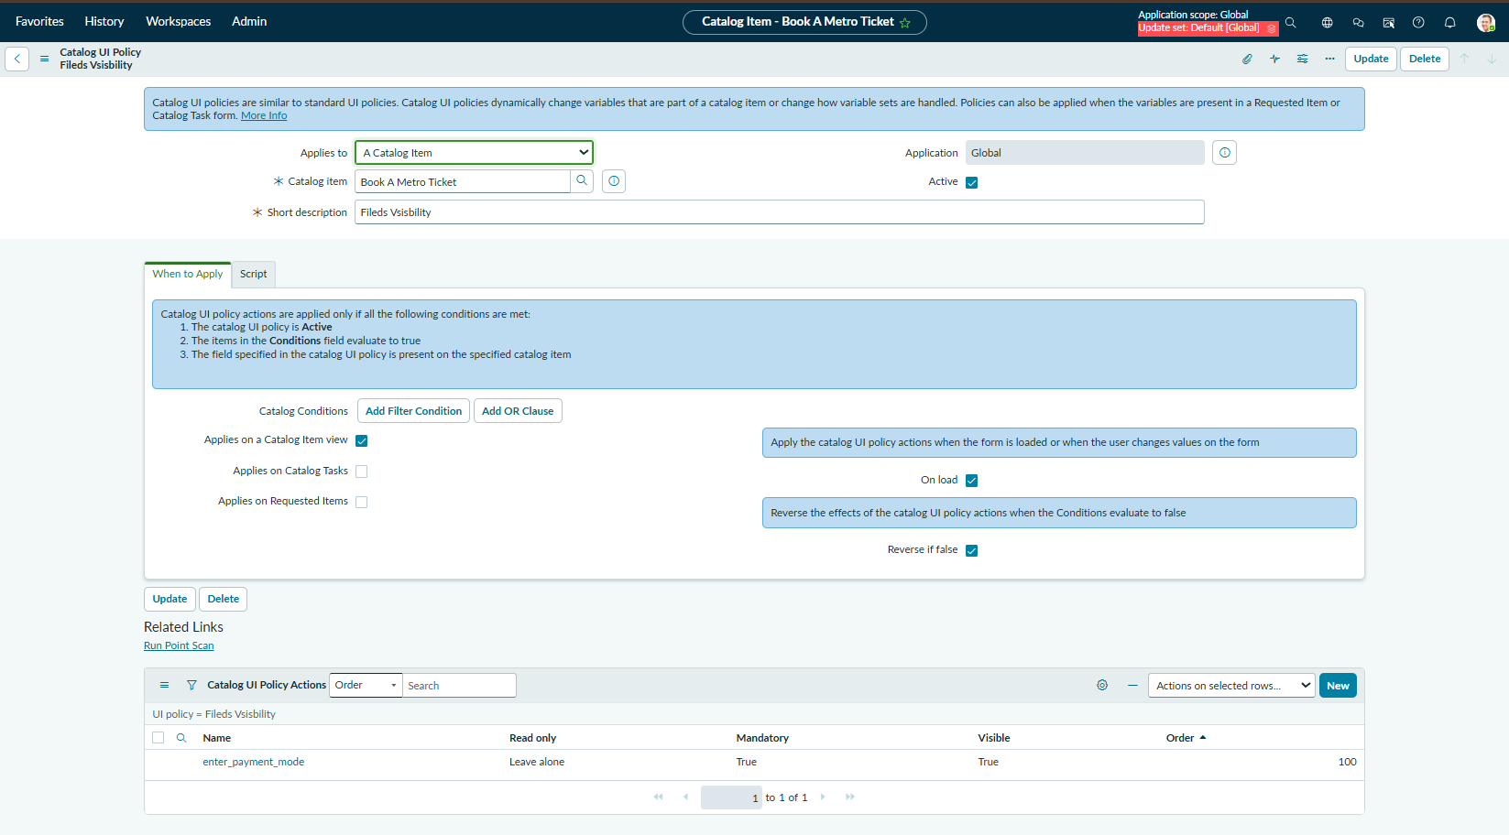
Screenshot 8 – Catalog Client Scripts list showing Fare auto-calculation and QR Generation.
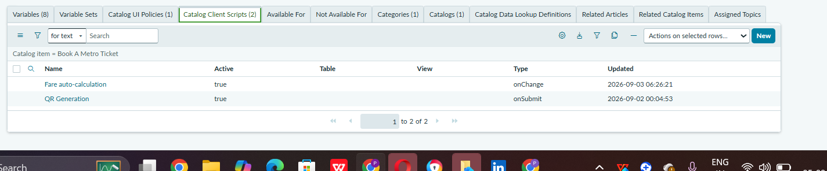
Screenshot 9 – Fare auto-calculation Catalog Client Script.
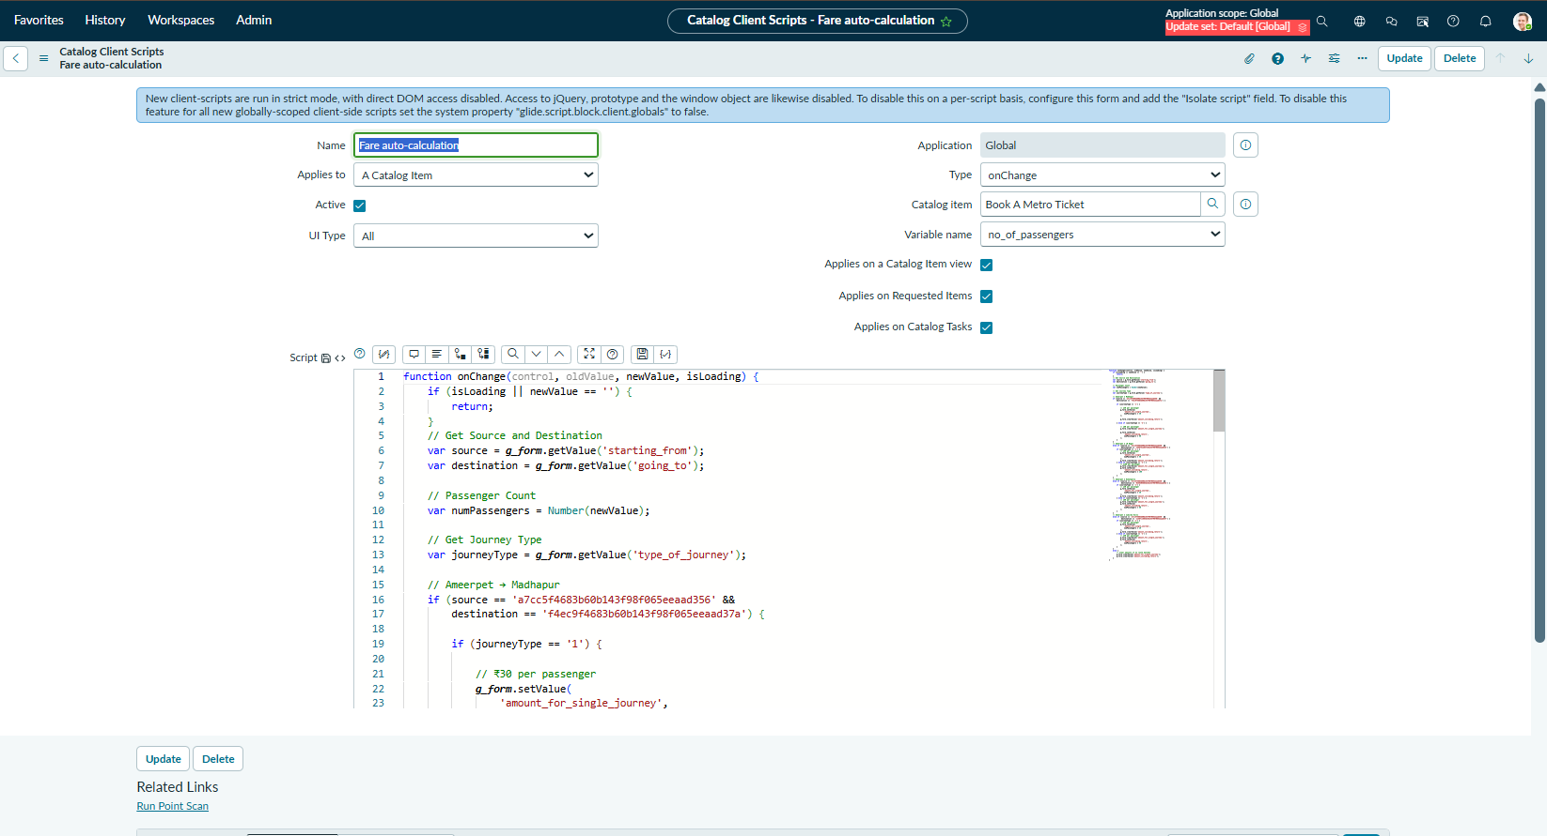
Screenshot 10 – QR Generation Catalog Client Script.
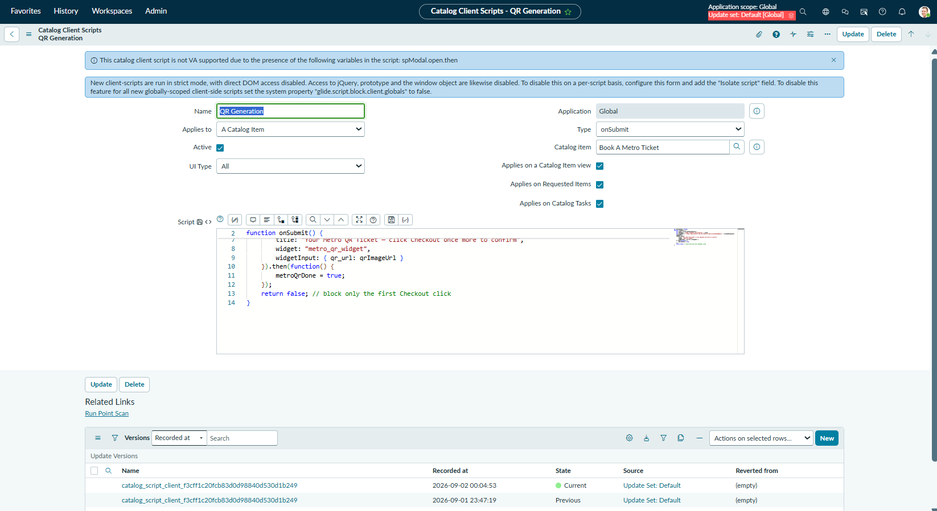
Screenshot 11 – Generated Metro Ticket QR code displayed to the user.
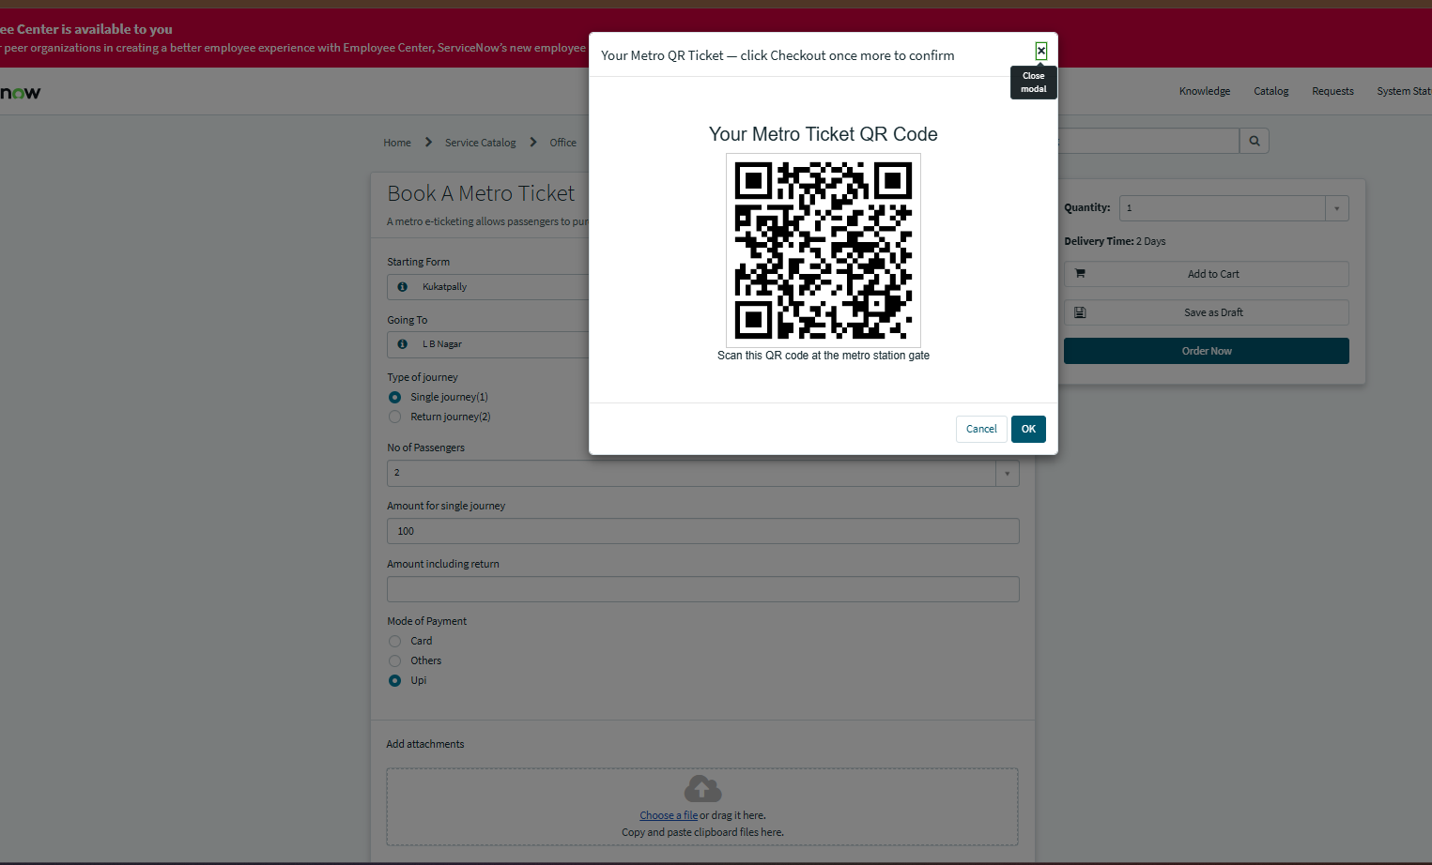
Screenshot 12 – Book A Metro Ticket form with route, journey, passenger, fare and payment fields.
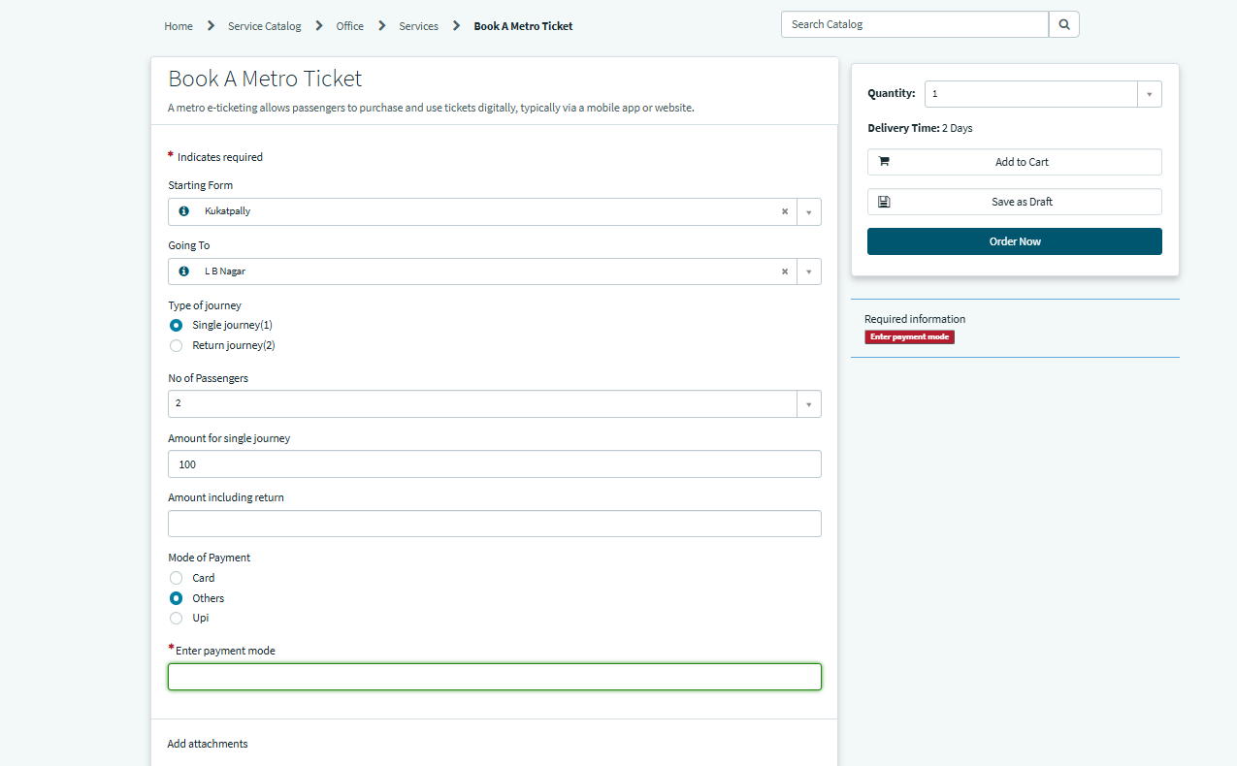

Conclusion
The supplied screenshots provide implementation evidence for the Metro Ticket Generating System in ServiceNow, including database tables, access controls, service catalog configuration, variables, UI policy, client scripts, fare calculation and QR-code generation.

